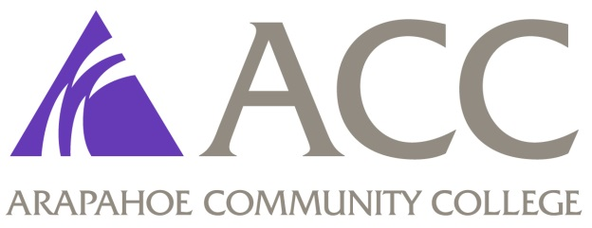

COVID-19
I understand and acknowledge that I must have a COVID-19 vaccine (one dose of Johnson & Johnson or two doses of Pfizer or Moderna) AND a COVID-19 booster. When additional future boosters are recommended by the CDC, they will also be required during the nursing program. Students will be required to complete all clinical hours in a variety of healthcare settings caring for vulnerable populations. I understand that while ACC may offer exemptions, the clinical sites will not for students. No titers will be accepted. No exemptions will be made.

By checking the box, I accept and acknowledge the above COVID-19 vaccination information: ☐

Name, date
Academic Healthcare Licensure Portability Information SARA:

Students enrolling or continuing at Arapahoe Community College (ACC) have a right to certain information that the college is required by law to provide. As a student applying for or attending the Associates Degree Nursing Program or Practical Nursing Exit Option, you have the right to know it meets the licensure or certification for Colorado. It is possible that the degree/certificate may count toward licensing in states other than Colorado. If you are planning to seek professional licensure, it is strongly recommended that you contact the appropriate licensing entity in the state in which you are located or plan to locate in order to seek information and guidance regarding licensure or certification requirements before you begin this program. This program meets the applicable state prerequisites for licensure or certification in Colorado as listed below:
Colorado Board of Nursing
National Council State Board of Nursing NCLEX-RN and NCLEX-PN

ACC has not determined if the Associates Degree Nursing Program or Practical Nursing Exit option meets applicable state prerequisites for licensure or certification in states other than Colorado. Other states include (Alabama, Alaska, Arizona, Arkansas, California, Connecticut, District of Columbia, Delaware, Florida, Georgia, Hawaii, Idaho, Illinois, Indiana, Iowa, Kansas, Kentucky, Louisiana, Maine, Maryland, Michigan, Minnesota, Mississippi, Missouri, Montana, Nebraska, Nevada, New Hampshire, New Jersey, New Mexico, New York, North Dakota, Ohio, Oklahoma, Oregon, Pennsylvania, Rhode Island, South Carolina, South Dakota, Tennessee, Texas, Utah, Vermont, Virginia, Washington, West Virginia, Wisconsin, Wyoming and U.S. Territories: American Samoa, Guam, Northern Mariana Islands, Puerto Rico, and the U.S. Virgin Islands). For additional licensing requirements by state, see: https://www.ncsbn.org/14730.htm

By checking the box, I accept and acknowledge receipt of the above licensing information: ☐

Name/Date_________________________________

