All You Need to Know about Registering for and Signing In to myClinicalExchange
Dear myClinicalExchange Student,
Welcome to the mCE program where we are making your clinical rotations more organized, more efficient and easy to manage! This letter is divided into two parts: Registration Directions which are followed by Instructions on How to Log In.

Registering for myClinicalExchange
Navigate to https://register.myclinicalexchange.com (we recommend that you follow this link or copy/paste it into your web browser. Internet Explorer 8x or 9x is preferred certified browser for our app). You will be navigated to a registration page like this one.
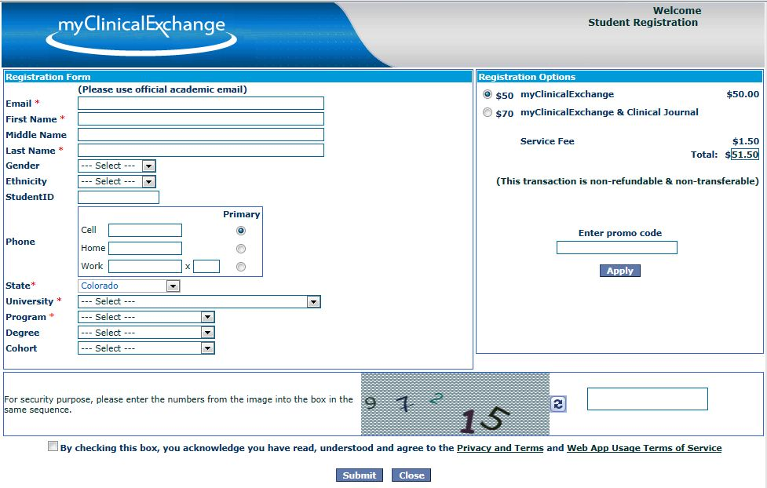
Fill out all the information possible on the left side including:
University: . Program: . Cohort: __________.
Anything with a red asterisk is required. Please use your official e-mail address issued to you by your Academic Institution and NOT a personal email such as gmail, aol, yahoo etc.

On the right side, select the top option if you only want access to the mCE platform. Choose the second option ONLY if your University is also using eStarPortfolio.
If your Academic Institution is a member of ACE, please enter the Promo Code COACE to receive the discounted price of $36.50 ($35 + $1.50 service fee) and click “Apply”.
There are NO refunds and NO transfers if you purchase the wrong item, forget to enter the Promo Code or leave your University’s Program!!!
Read the Privacy and Terms and Web App Usage Terms of Service before checking the box on the bottom right. Click “Submit” and you will be navigated to the payment page.
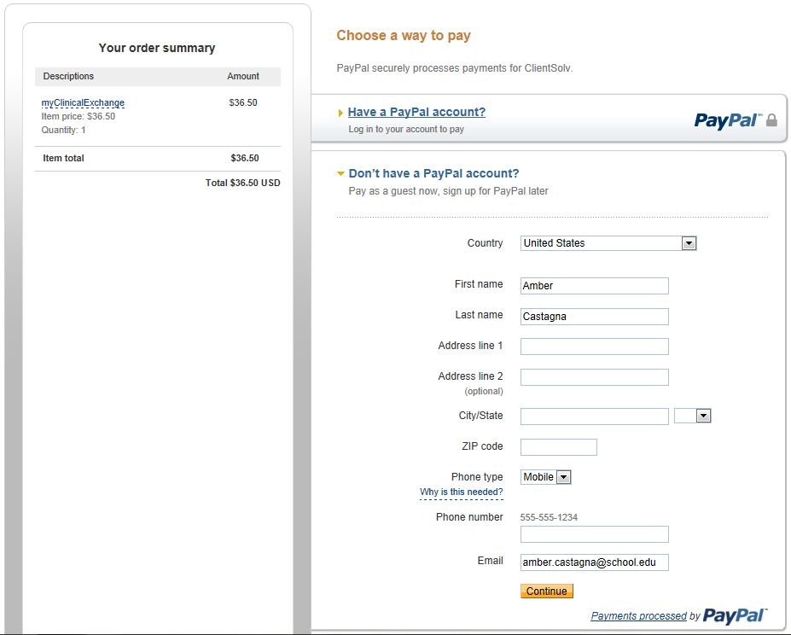
Review the pricing on the left. Make sure your promo code has dropped the total price to $36.50. If you already have a PayPal account, choose the option at the top, log in and pay via your PayPal account.
If you do not have a PayPal Account, fill in all the information in the lower box and click “Continue”. You are navigated to the payment page.
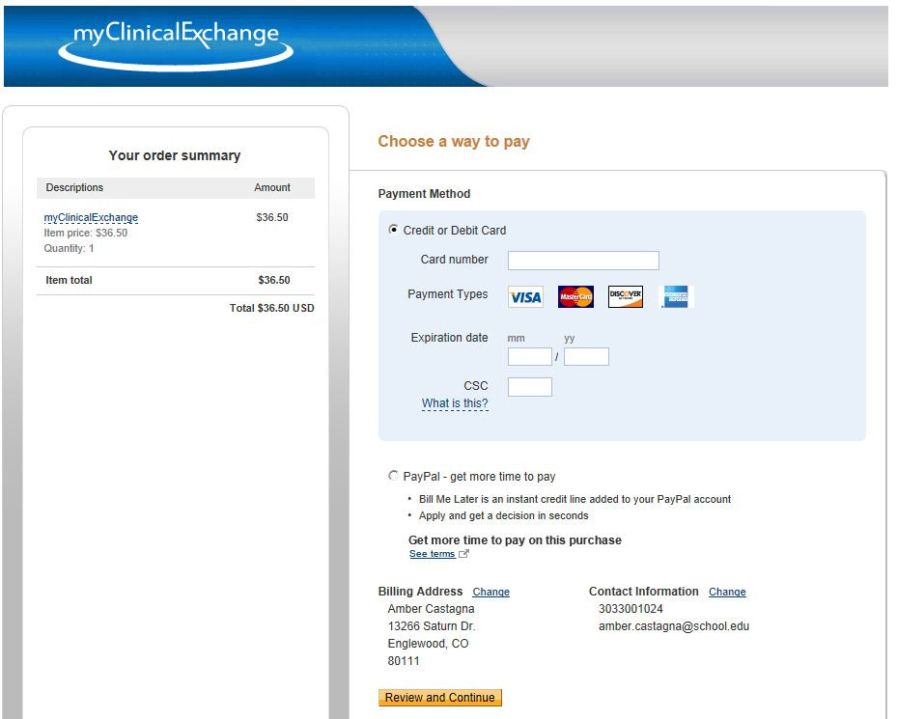
Fill in your credit card information. Click “Review and Continue” at the bottom of the page to review your final purchase.
After reviewing click the final submit button. A confirmation page will appear showing that you have paid and giving you a receipt number. Keep this for your records.
You are now registered for myClinicalExchange and can be scheduled into a rotation. At that time, read below for instructions on how to log into myClinicalExchange for the first time.

Logging into myClinicalExchange
At the current time, your Academic Institution and the Hospitals are entering and approving your upcoming clinical rotations. When a rotation has been entered, approved and you have been scheduled, you will receive an e-mail from the myClinicalExchange system asking you to log on.
When you receive this notification e-mail, navigate to https://myclinicalexchange.com (we recommend that you follow this link or copy/paste it into your web browser. Internet Explorer 8x or 9x is preferred certified browser for our app). Click on the “Forgot Password?” link in the upper right corner and the mCE system will prompt you for your Username which is your school- issued e-mail address. All Usernames were created using the e-mail address you used to register for mCE in the previous step (which should have been your school-issued e-mail address). Your password will also be e-mailed to this address. The system will not recognize a different e-mail address (such as gmail, yahoo etc.) and you will not receive an e-mail with your password.
Please check your inbox for an e-mail from donot-reply@myclinicalexchange.com assigning you a password. If you do not see an e-mail from this address, please check your junk folder. You will want to designate donot-reply@myclinicalexchange.com as a “Safe Sender” so that further e-mails from myClinicalExchange come directly to your inbox. If you still do not see the e-mail or if you are receiving an error message from the system when you try to get your password, please see the troubleshooting tips on the next page.
Once you log in please do the following:
- Click your name in the upper right corner to reset your password with a password of your choice.
- Your Home Screen will display any rotations that have been approved by the “network” of Hospitals and by your Academic Institution. You will also be able to see the rotation details and all related documents. Click on the hyperlinked “Rotational Documents”. This will navigate you to a new page where you can view documents pushed to your from the Hospital, give electronic consent to items and upload and required documents.
- Watch the training videos by clicking on the link in the upper right corner. These brief videos will show you how to quickly and easily navigate the mCE site.
If your screen is blank, that means you have not yet been scheduled for a rotation in the mCE system. Please contact your Clinical Coordinator at your school to resolve this issue.
If you have registered for mCE plus the Portfolio (clinical journal), please be aware that the system will be activated after configuration and initial set up with your Academic Institution.
If you have any questions, please contact the Clinical Coordinator at your Academic Institution. We wish you a successful year and trust you will find mCE a simple and helpful tool in your academic career.

If you have problems signing into mCE please answer the following questions:

- What e-mail address are you using? Please make sure to use the e-mail address you registered with on Pay Pal. This SHOULD be your school-issued e-mail address, however you may have registered/paid with a personal e-mail address.
- Have you checked your junk mail folder? The e-mail will be from donot-reply@myclinicalexchange.com. Please mark e-mails from the domain “myclinicalexchange.com” as a “Safe Sender” so that future correspondence comes immediately to your inbox.
- What kind of computer are you using? A Mac or a PC? The myClinicalExchange application does not work well on a Mac. It is possible to view some of the information but we highly recommend using a PC.
- If you are on a PC, are you running Windows 8? Windows 8 is a little too new for our application. To work around this, open Internet Explorer and navigate to the mCE site but don’t log in.
  - On the right side of the address bar is an icon that looks like a sheet of paper torn in two across the middle. Click on this icon to go to “Compatibility View” which will allow you to view/run myClinicalExchange on a Windows 8 computer.
  - If you do not see this icon, you can manually add mCE. From the menu at the top left, click the “Tools” menu and select “Compatibility View Settings”. (If you do not see the “Tools” menu, press the “Alt” key on your keyboard and the menu will show.) A pop up window will appear. In the top text box, the web address for mCE will be listed. Click Add and the web address will then appear in the large box below. You have just added mCE to the list
- What web browser are you using? Google, Firefox? myClinicalExchange was built to work with Internet Explorer 8 or 9. Please do not use Safari, Google Chrome etc.

Please use a PC computer that runs Internet Explorer 8 or 9. Once you are on a computer system that meets these requirements, you will need to click the “Forgot Password?” link again so that an e-mail can be sent with your password.

If, after all of this, you are STILL not able to sign on then please do the following:
- What kind of message are you getting? If you get a red message of any kind (ie “Error” or “E-mail has been sent” etc.), please mark down what it says – this will help the IT department at mCE figure out what is wrong.
- Send your name, the error message (from above) and your university-issued e-mail address to your Clinical Coordinator at your school. They will forward the message to the mCE Support Staff who will troubleshoot the issue from there. Amber, from mCE, may contact you for further information.

