Instructions to Order ACC Graduation Regalia Set – Available April 1st
Sign in if you have an existing account at ArapahoeShop.com (if not, it’s easy and free to create)
Access the Graduation Regalia Set, or select the Shop menu, Graduation, Graduation Regalia Set

ACC will cover the cost of your regalia set (cap, gown, tassel), standard shipping and tax.
- To place your order
  - In the dropdown select your Height and Weight range
  - In the Degree Box, enter: Bachelor, Associate or Certificate
  - Quantity = 1
  - Add to Bag
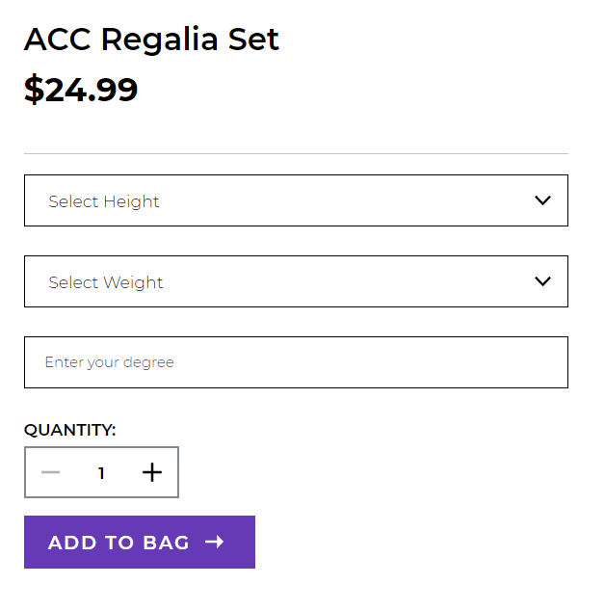

- Click on “View Bag and Checkout”
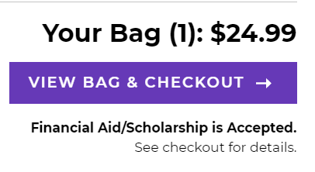
- Click Checkout from the Order Summary Screen
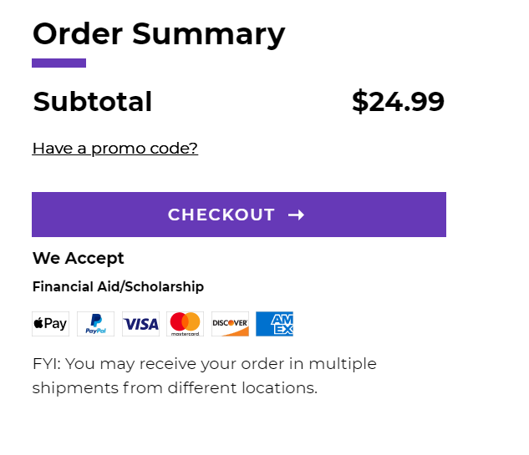
- Delivery Method: Select “Ship to an Address” and “Standard Shipping” only (store pick up is not available). Confirm the address that appears. Regalia orders will begin shipping the week of April 19th.
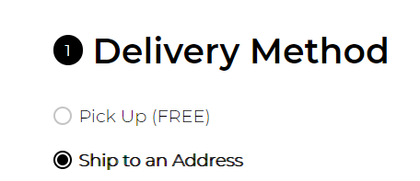

- Proceed to Payment:
- Check the box marked “Financial Aid / Scholarship”
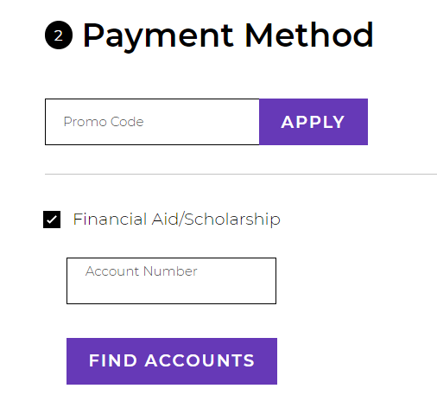
- Account Number, enter your Student ID number (your “S” number)
- Click Find Accounts
  - If your S# cannot be found, please contact the bookstore. S# are being updated daily as students select their Commencement time slot
- Click “Please agree to Terms & Conditions”
- Click “Pay With This”
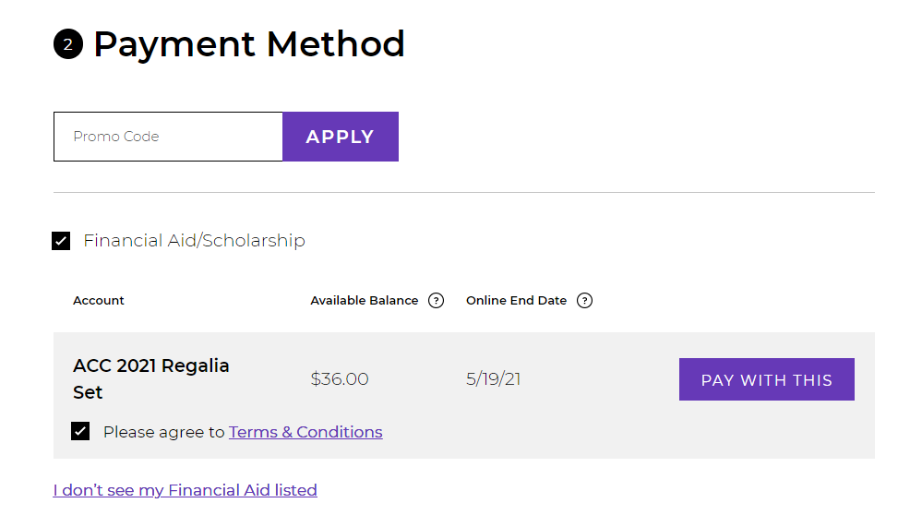
- Order Summary Total will adjust after accepting terms and clicking pay with this
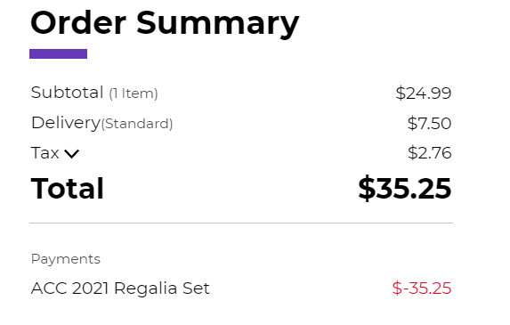

- Place Order
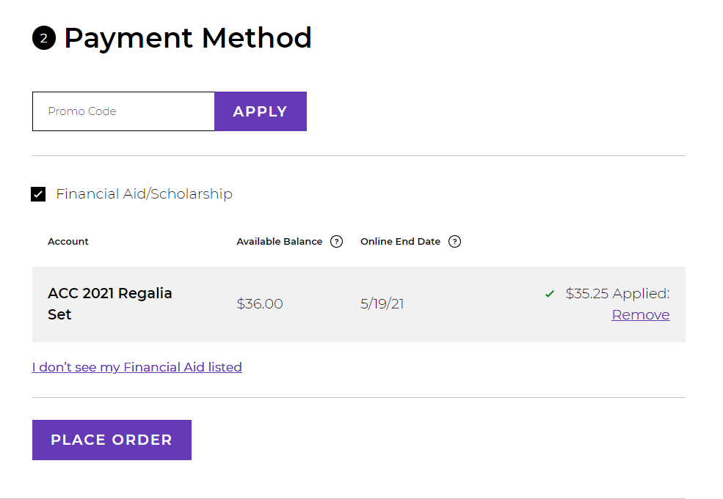
- Order placed confirmation; email confirmation will also be sent
