Instructions to Order ACC Graduation Regalia Set
Sign in if you have an existing account at ArapahoeShop.com (if not, it’s easy and free to create)
Access the Graduation Regalia Set, select the Shop menu, Graduation, Graduation Regalia Set

ACC will cover the cost of your regalia set (cap, gown, tassel) and standard shipping; tax does not apply to the regalia set. Screenshots below may differ from the actual site.
- To place your order your regalia set
  - In the dropdown select your Height and Weight range
  - In the Degree Box, enter: Bachelor, Associate or Certificate
  - Quantity = 1
  - Add to Bag
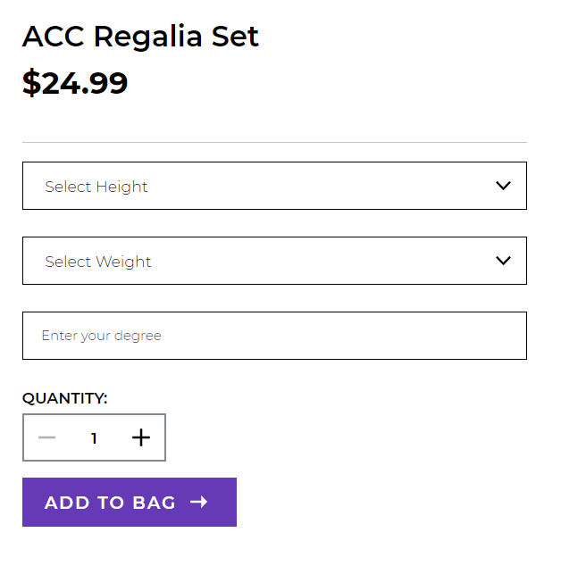

- Click on “View Bag and Checkout”
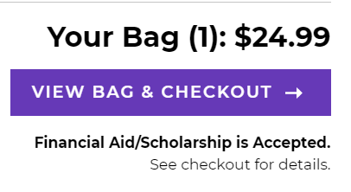
- Click Checkout from the Order Summary Screen
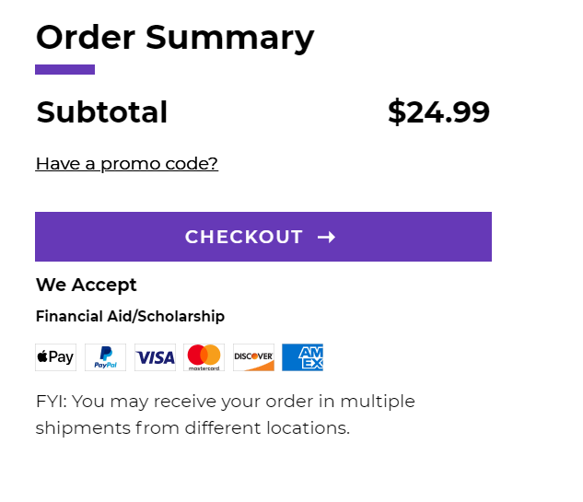

- Delivery Method:
  - Orders placed BEFORE May 10, 2022 or students outside of Colorado: Select “Ship to an Address” and “Standard Shipping” only (store pick up is not available). Confirm the address that appears. You will be notified by email with a tracking # as soon as your order ships from the bookstore.
  - Orders placed AFTER May 10, 2022: Select “Pick Up”. You will be notified by email from the bookstore when your order is available.
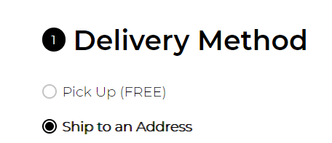
- Proceed to Payment:
- Check the box marked “Financial Aid / Scholarship”
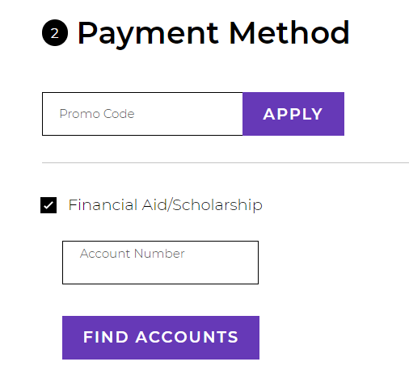
- Account Number, enter your Student ID number (your “S” number)
- Click Find Accounts
  - If your S# cannot be found, please contact the bookstore. S# are being updated daily as students select their Commencement time slot
- Click “Please agree to Terms & Conditions”
- Click “Pay With This”
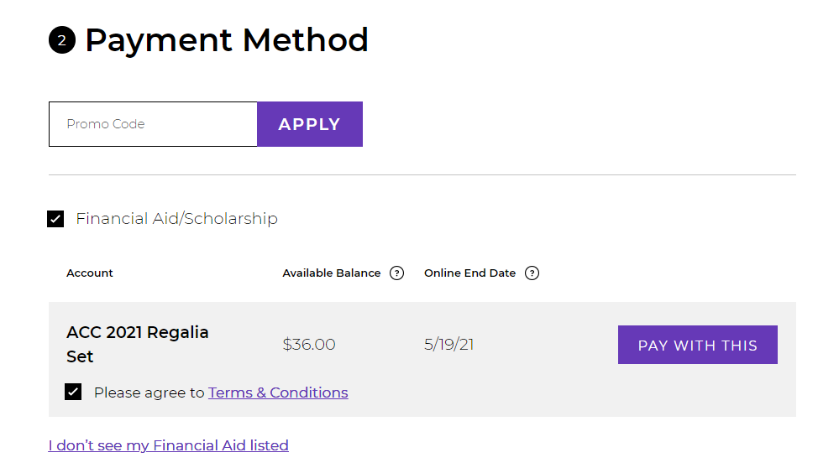
- Order Summary Total will adjust after accepting terms and clicking “pay with this”. Please note: tax will not be applied to your order for your regalia set.
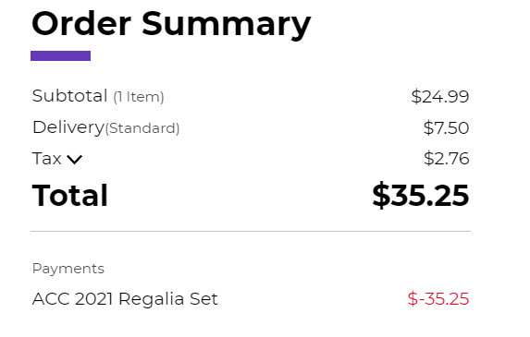
- Place Order
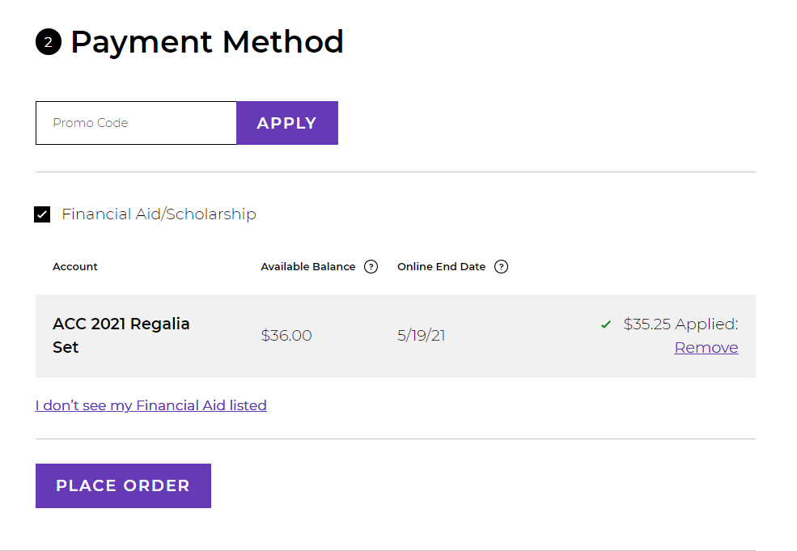
- Order placed confirmation; email confirmation will also be sent
